Distance Weighted Discrimination

Task 2.12.2 – User Guide for DWD with Visual Diagnostics

Copyright and License page

- You can download Java jre at http://java.sun.com/j2se/1.4.2/download.html.
- You can download DWD at: https://genome.unc.edu/pubsup/dwd/.
- You can download TextPad at: http://www.textpad.com/download/
- Installation test suite or test plan: The test suite related to installation is documented in the DWD_UNC_Test_Activity_Log_Complete.doc . You can download this file at: http://cabigcvs.nci.nih.gov/viewcvs/viewcvs.cgi/distanceweighteddiscrimination/DWD_UNC/Month_11/DWD_UNC_Test_Activity_Log_Complete.doc.

Insert Names of Development Team(s) here
Development | User’s Guide |  | Program Management
Steven Marron¹ | Steven Marron¹ |  | Juli Klemm³
Xuxin Liu¹ | Xuxin Liu¹
Xingliang Zhou¹ | Xingliang Zhou¹
 | Louise Showe²
 | Michael Showe²
 | Michael Nebozhyn²
¹ UNC, Chapel Hill, NC, ² Wistar Institute, Philadelphia, PA, ³ 3rd Millennium, Inc., Washington, DC

Contacts and Support
Enter training contact | Michael Showe (showe@wistar.org)
Enter customer support contact | http://www.wistar.upenn.edu/showe/  Telephone: 215-898-3791  Toll free: N/A

LISTSERV Facilities Pertinent to software teams
LISTSERV | URL | Name
caBIO_Users | https://list.nih.gov/archives/cabio_users.html | caBIO Users Discussion Forum
caBIO_Developers | https://list.nih.gov/archives/cabio_developers.html | caBIO Developers Discussion Forum
caDSR_Users | https://list.nih.gov/archives/cadsr_users.html | Cancer Data Standards Repository
NCIEVS-L Listserv | https://list.nih.gov/archives/ncievs-l.html | NCI Vocabulary Services Information

Table of Contents

Chapter 1 Introduction to the Manual 1
Purpose and objectives of the manual 1
How to use the manual 1
Organization of the Technical Guide 1
Chapter 2 Introduction and overview of the Software 2
Background of the Application 2
Brief introduction to the software architecture and major components 2
caBIGTM compatibility level 3
Software and hardware dependencies 4
Chapter 3 Using Java-based DWD software 5
System preparation and set-up 5
Installing the software 5
Initialization/configuration of files, variables, data 5
Initial software startup 6
Interrupt/recovery/restart 6
Tailoring, reconfiguration, adaptation 6
Re-initialization after failure 6
Notes Related to Data Files 6
Data set format 6
Parameter selection 7
Output 8
Example of typical usage 8
Related documents 22
DWD Software Requirements and Specification 22
DWD User’s Guide (this document) 22
DWD Administration Manual 22
DWD User Guide (README.txt) 22
DWD test activity log 23
For earlier Matlab versions of DWD 23
The original DWD paper 23
First application of DWD to microarray data 23
Startup and termination 24
Standard operating procedures 24
Sign Off 25
Appendix A Glossary 26

Introduction to the Manual

Purpose and objectives of the manual
This document was created to provide the information necessary to use DWD . The information on installation, configuration, and system administration instructions are provided in the DWD Application System Installation and Administration Reference Manual that can be downloaded from the caBIG website.

How to use the manual
This manual is divided into 3 chapters. Chapter 1 describes the organization of the manual. Chapter 2 provides a background and brief overview of the purpose and features of DWD, the data formats that can be used and control options that are available.
Chapter 3 contains detailed instructions on how to perform DWD-based systematic bias adjustment.

Organization of the Technical Guide
Chapters | Contents
Chapter 1 – Introduction to the Manual | Purpose and objectives of the manual  How to use the manual.
Chapter 2 – Introduction and overview of the software | Background of DWD  Brief introduction to the software architecture and major components  caBIG™ compatibility level  Software and hardware dependencies
Chapter 3 – Using Java-based DWD software | System preparation and set-up  Installing the software  Initialization/configuration of files, variables, data  Initial software startup  Interrupt/recovery/restart  Tailoring, reconfiguration, adaptation  Re-initialization after failure  Some Notes Related to Data Files  Example of typical usage  Related documents

Introduction and overview of the Software
This chapter provides an overview of the software.
- Background of the application
- Brief introduction to the software architecture and major components
- caBIG™ compatibility level
- Software and hardware dependencies

Background of the Application
DWD origins can be traced back to the research on meta-analysis of several microarray datasets conducted at UNC Lineberger Comprehensive Cancer Center (Lineberger). Large microarray datasets have inherent systematic biases due to multiple experimental factors that can include different sources of RNA, different batches of microarrays, different users and especially different microarray platforms. The effects of these biases on the gene expression can cause significant interference with the biological patterns that investigators are trying to quantify. To address this challenge, Dr. Marron and collaborators developed a tool called Distance Weighted Discrimination (DWD) that makes statistical corrections to reduce the effect of these biases on the gene expression data. The approach is based on modern statistical discrimination methods and DWD has been shown to be better than Support Vector Machines and Singular Value Decomposition for the adjustment of systematic biases (Benito et al, 2004). The presented version of Java-based implementation of DWD algorithm was developed and implemented as part of caBIG through collaboration of the developer team at UNC and adopter team at the Wistar Institute.

Brief introduction to the software architecture and major components
There are three major components for Java version DWD. They are:

- Java GUI Component for Data Adjustment;
- DWD Adjustment Component;
- Java GUI Component for Data Visualization.

The relationships between there major components described above, are illustrated in the following process flow chart (Figure 1), which shows the logical function of the software. Rectangles represent menus visible to the user, and the text inside represents tasks, with (BT) representing buttons.

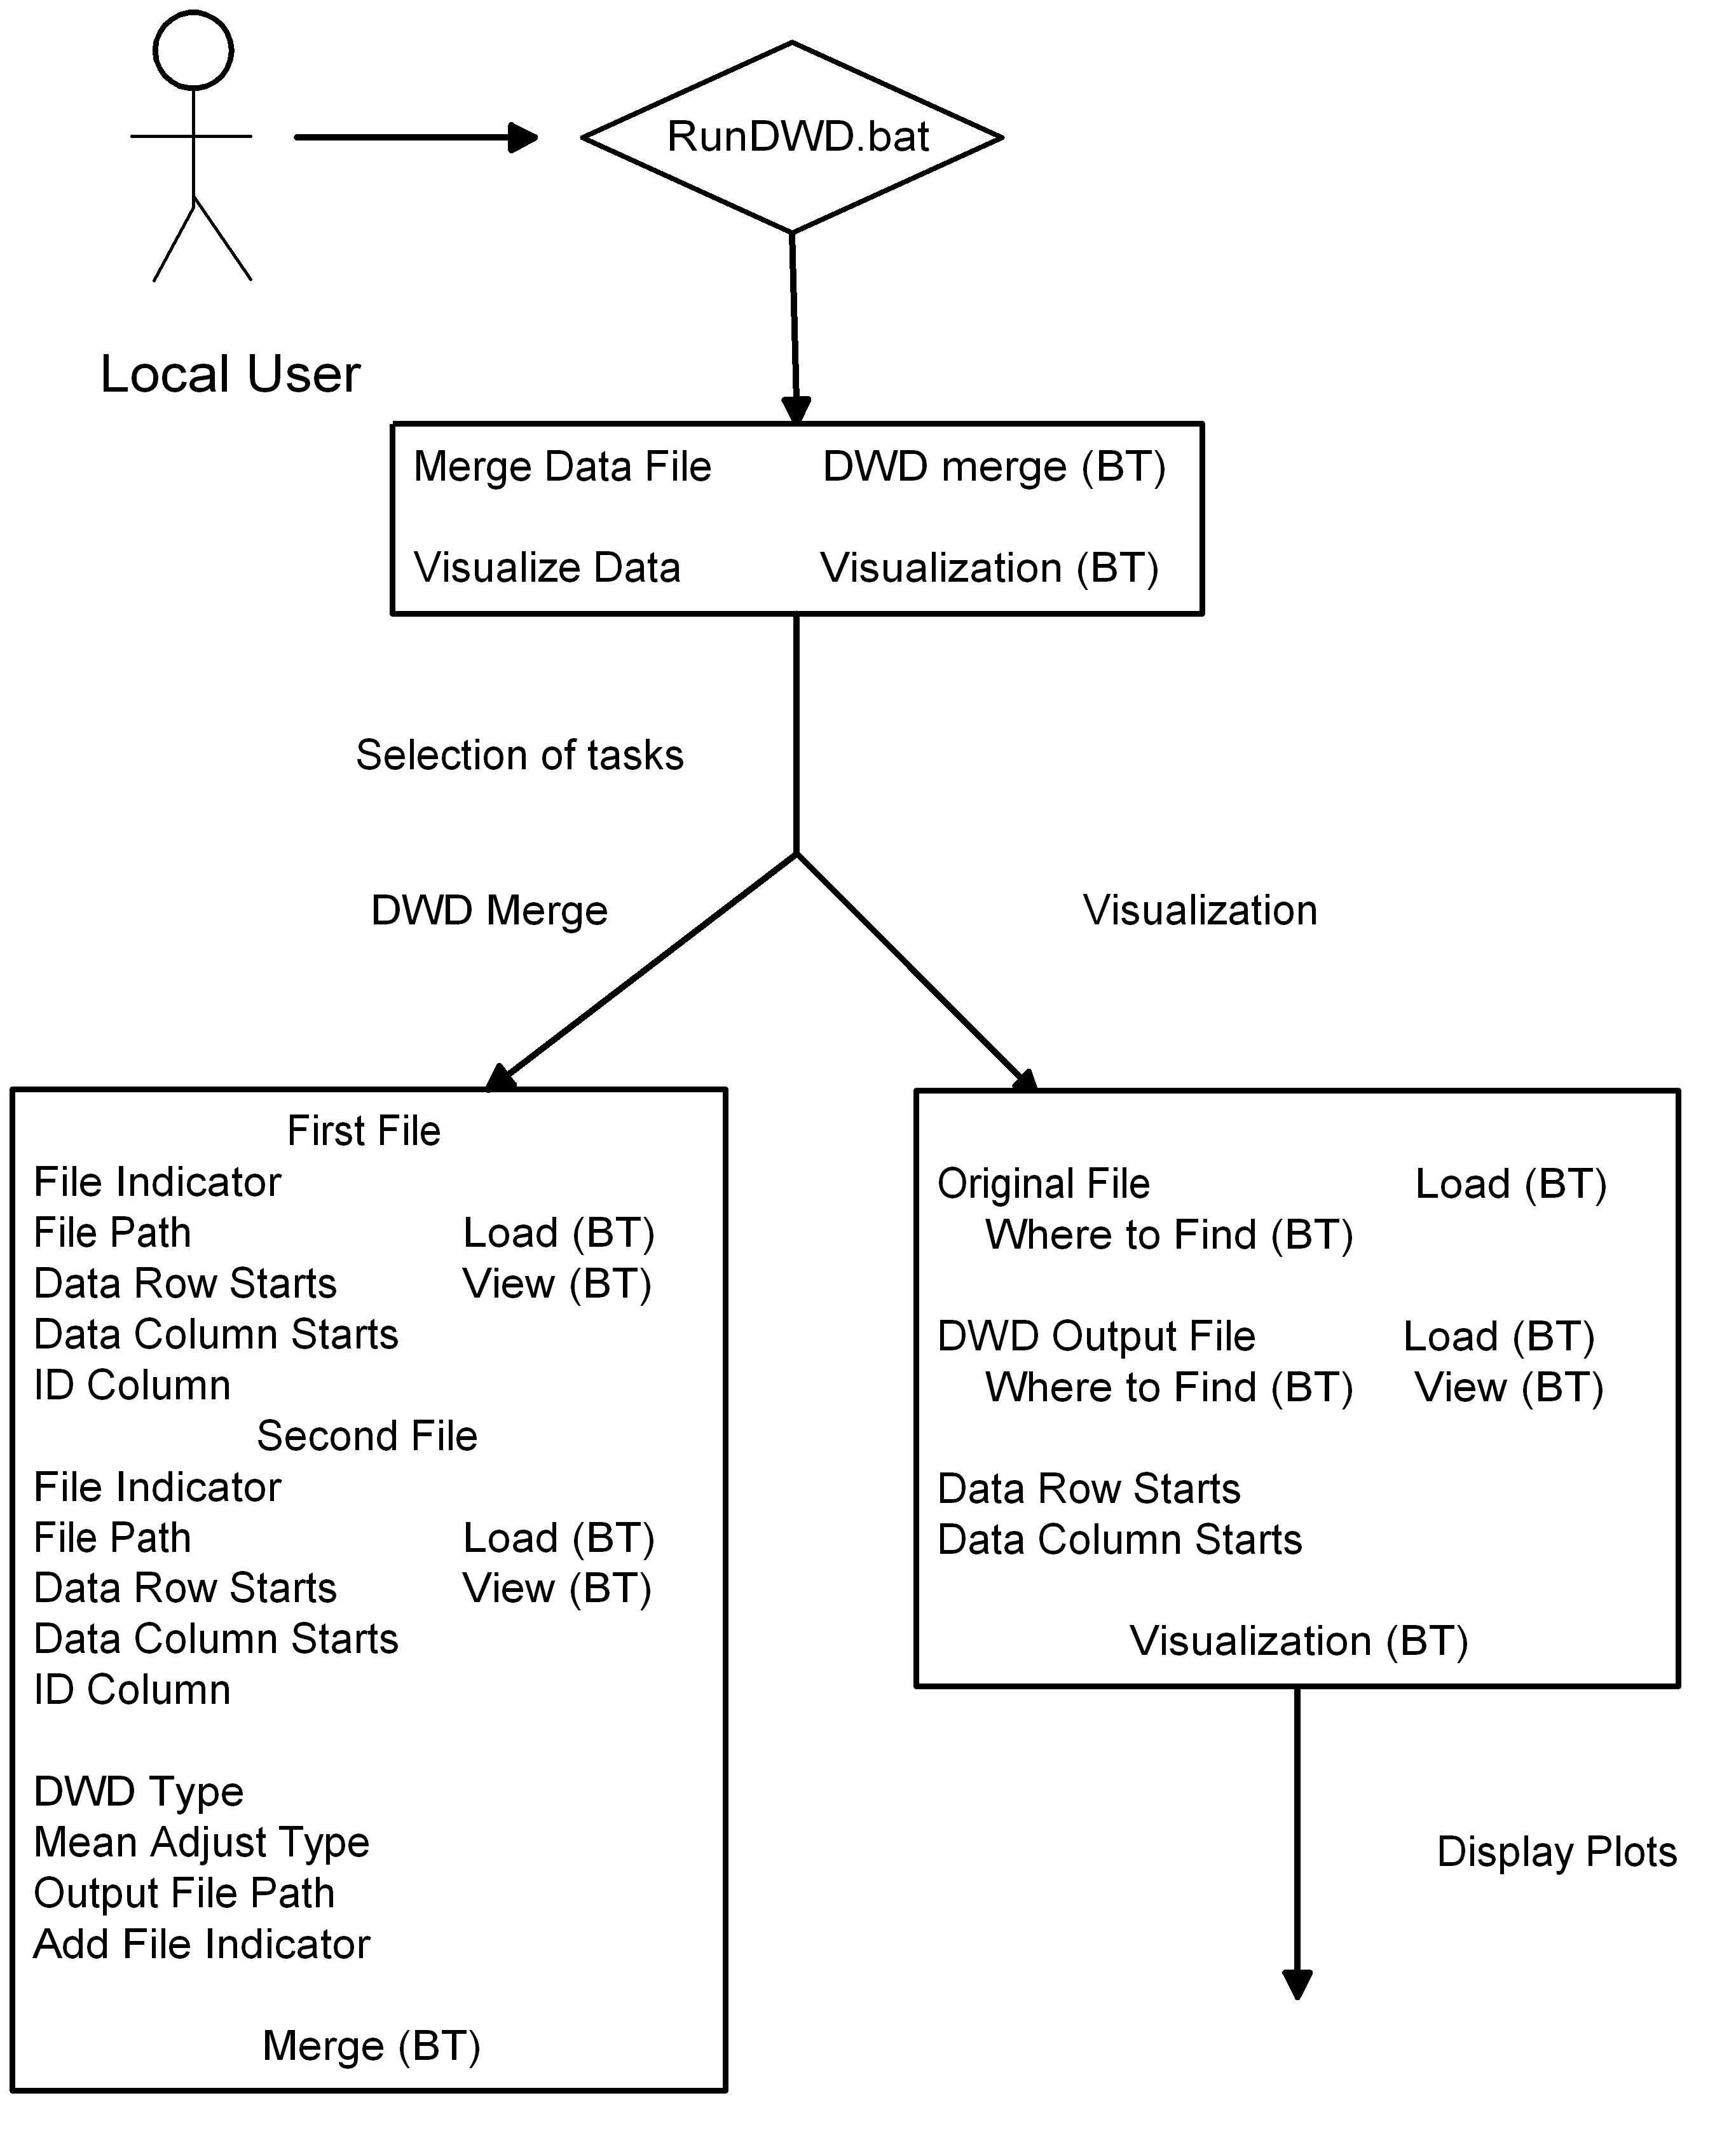

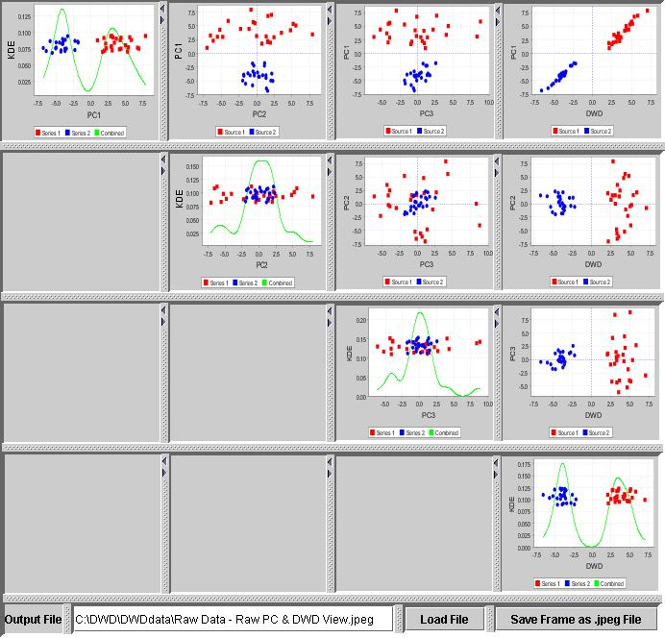

DWD analysis flowchart

caBIGTM compatibility level
The current implementation of the DWD system meets the silver level of caBIG™ compatibility. The current DWD can import MAGE-ML files and do adjustment, then output the adjusted data as MAGE-ML file.

Software and hardware dependencies

The current DWD only runs on Window OS machine. Java jre 1.4 or above must be installed. If the input files are not very big, e.g. 10,000 genes and 300 samples, then a regular PC (Pentium III with 512 MB of RAM) is sufficient . However, when the sample size reaches >600, the visualization may take long time. This problem will be addressed in the Year 2 project.
When the input files are MAGE-ML and the files have many derived BioAssayData, a regular PC may not be enough. The suggested minimum required hardware configuration necessary to handle large MAGE-ML formatted input data is currently being established.

Using Java-based DWD software
Topics in this chapter include:
- System preparation and set-up
- Installing the software
- Initialization/configuration of files, variables, data
- Initial software startup
- Interrupt/recovery/restart
- Tailoring, reconfiguration, adaptation
- Re-initialization after failure
- Some Notes Related to Data Files
- Example of typical usage
- Related documents

System preparation and set-up
No special system set-up is needed, except installation of Java jre. You can download jre at http://java.sun.com/j2se/1.4.2/download.html.

Installing the software
DWD can be downloaded at : https://genome.unc.edu/pubsup/dwd/.
The current version of DWD is only tested on MS Windows XP and 2000. The software should be directly installed under c: drive, to avoid additional configuration. There are two subdirectories under the DWD directory: lib and DWDdata. There are also eight important files in the DWD directory: README.txt, RunDWD.bat, DWD.jar and five additional jar files.
The lib subdirectory contains all dynamic link libraries as well as executable files ported from Matlab..
The DWDdata subdirectory can house all data files, including the original ones and the output from DWD.
Note: You do not have to put your input and output files in this directory, but this folder is critical. If you delete this folder, an error message window will pop up to remind you of this.

Initialization/configuration of files, variables, data
If DWD is installed as above, no initialization/configuration is needed. All the variables and data will be provided during the running of software.

Initial software startup
There are two methods for running of DWD
Method 1: Start DOS command line window, change current directory to DWD, type RunDWD.bat.
Method 2: In windows explorer, double click RunDWD.bat.
I tend to use the method 1, because an error can be retained after you close DWD.

Interrupt/recovery/restart
To interrupt the application, close the GUI window or close DOS window. To restart the application, please follow the same steps as in Initial software startup.

Tailoring, reconfiguration, adaptation
N/A.

Re-initialization after failure
Same as interruption of application.

Notes Related to Data Files

Data set format
The current version of DWD can take Stanford-like text delimited file and MAGE-ML format files as input.
A. Stanford-like text delimited file.

The first column of the Stanford-like text delimited file is the probe identification, the second column contains probe annotation and the third column the values for the measured gene expression data. The gene identifiers must be unique (duplicates are not allowed). The first row contains information about the samples. This kind of input format has been extensively tested. Two sample files are also included in the DWDdata subdirectory. The software can also detect the missing elements and non-digit values where a digit value is supposed to be and report each error one by one each time. Two examples of already formatted sample data files are provided in DWD installation package (files Example1.txt and Example2.txt in subfolder C:\DWD\DWDdata) and snapshots of their contents are shown in Figures 4 and 5 on page 13 of this user’s guide. The contents of the first column may include spot id, affymetrix probe set id (when merging two datasets hybridized on the same platform), gene bank accession number, unigene cluster id, gene symbol, etc. The second column may contain gene name, unigene cluster, clone id, etc. The entries in the third and subsequent columns should contain numerical values of measured gene expression data and can be either in standard floating point form (for example, (+/-)1.2567), or in scientific form (for example, -1.25E-2).
Missing or non-numerical values (NaN) values should be imputed before submitting the data. See http://bioinformatics.oupjournals.org/cgi/reprint/17/6/520.pdf for a good introduction to methods typically used for, imputation, and see http://www.scripps.edu/researchservices/dna_array/new/Data_Analysis_SAM.htm for imputation software. When you edit the files with MS Excel, delete any blank lines. We suggest using the TextPad editor to modify your files. It can be downloaded at: http://www.textpad.com/download/

B. MAGE-ML format file.
The DWD developer team at UNC have tested files generated from Agilent and Affymetrix, with internal data and external data files. At this time, validation with MAGE-ML.dtd does not function properly but can be used with the following work-around. To avoid problems delete the lines related to MAGE-ML.dtd in the .xml input files. To date, the DWD software has only been extensively tested using only Stanford-style formatted input and the enquiries for further information regarding MAGE-ML input option, should be sent to the DWD developer team.

Parameter selection

A. For Stanford-like text delimited file.
Options are clear, as displayed on the GUI.

B. For MAGE-ML format file.
When MAGE-ML format files are used as input, there are a few criteria we adopt.
(1). If there are both raw data (MeasuredBioAssayData) and derived data (DerivedBioAssayData), only derived data will be retrieved for data adjustment.
(2). If there is more than one raw data/derived data sets in the one MAGE-ML file, they must all be adjusted before continuing.
(3). If you want to re-run the data adjustment, you have to restart DWD. The button "Reset" in both the BioAssayData selection menu and the Quantitation selection menu will only reset those two parameters.

Output

A. For Stanford-like text delimited file.
The output files include: DWD_input.txt, DWD_Vec.txt, and DWD_Non_Std_Output.txt/ DWD_Std_Output.txt (if you use default output). DWD_Non_Std_Output.txt/ DWD_Std_Output.txt is the final output corresponding to the two DWD types. Note that the order of genes in the output files is different from that of input files. The rows in the output files are sorted based on the gene identification column in the ascending order. But other files (DWD_input.txt and DWD_Vec.txt) will also be used in the visual diagnostics analysis. Please do not delete them. They are automatically overwritten from one run of DWD to another.

B. For MAGE-ML format file.
In addition to the same files generated as above, there are two extra output files, when MAGE-ML format files are used as input. They are ExternalAdjustedDataFile.txt and DWD_Non_Std_Output.xml/ DWD_Std_Output.xml (if you use default output). The adjusted data will be stored in an external text file named ExternalAdjustedDataFile.txt. The text file, DWD_Non_Std_Output.txt/ DWD_Std_Output.txt (if you use default output) will be used for the visualization. MAGE-ML output can only be generated when both input files are MAGE-ML formatted.

Example of typical usage
This section describes typical usage of the Java-based implementation of the DWD algorithm. It relies on a sample input files Stanford-type format Example1.txt and Example2.txt provided with the standard DWD installation package.
1. Starting DWD application As was previously pointed out in the Initial Software Startup section , DWD application can be started either by calling a command prompt from Windows, or by double-clicking RunDWD.bat file in C:\DWD directory. Using the latter approach would lead to a new pop-up window as shown in Figure 2.
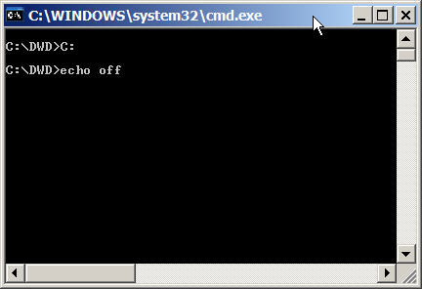
Figure 1. Command Prompt pop-up window appearing after clicking RunDWD.bat

2. Selecting a Task
After pop-up window shown in Figure 1, the user is presented with another pop-up window (Figure 2) containing the choice of tasks such as DWD-based merging of two data files in Stanford-style ASCII format, DWD-based merging of two input files that are both in MAGE-ML format. The button for the third option to visualize the output data is present as well, but should be used only after completion of DWD-adjustment. At the time that this manual was being written, the MAGE-ML option could not be tested due to lack of availability of relevant MAGE-ML files, therefore, the attention will be restricted to Stanford-style formatted input. Selecting first option “DWD Merge Stanford Format Data” leads user to the pop-up window allowing to specify the input parameters as shown in Figure 3.
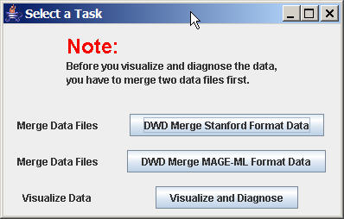
Figure 2. Task Selection Window

3. Specifying the parameters for the computation of DWD-based systematic bias correction in the case of Stanford-style formatted data input
The pop-up window shown in Figure 3 allows user to specify a set of parameters relevant to the case when both input files with gene expression values are formatted following the previously outlined Stanford-style convention. The fields for the input parameters are grouped according to their affiliation: first come those pertaining to the location and the layout of the two input files, then those specifying details of the DWD-adjustment, and finally those describing the output results. The explanation for these fields is given below.
File Out Indicator: Specifies the value of the text label that will be used to display the original input dataset membership in the generated output file.
File Path: Specifies the full (not relative) path to the input data file.
Data Row Starts at: Specifies the first row in the input text file that contains gene expression values.
Data Column Starts at: Specifies the first column in the input text file that contains gene expression values (the previous columns may contain various spot annotation information, such as spot id, unigene cluster, accession number, gene name, gene symbol, affymetrix probe set id, etc.).
Identifier Column: Specifies the order of the column (counting from the left) that contains row identifier that is to be used for matching rows/genes in two separate input files. It is expected that within each file, the entries in this column should be unique.
DWD Type: Specifies which type of DWD adjustment is to be performed. The default option is Standardized DWD and involves column wise standardization (z-score transformation) of every sample in both input data files. Column wise standardization consists in substituting the input gene expression values within each input sample by the corresponding z-score (subtracting mean gene expression value for the sample with subsequent division by the corresponding standard deviation). Within each input data file, for each sample, the mean value and the standard deviation are calculated using all rows in the corresponding input file, i.e. prior to establishing a smaller gene set common between two datasets that DWD is being applied to merge. The second option, Non-standardized DWD, performs DWD adjustment without preliminary column standardization on the columns of the input gene expression data.
Mean Adjustment Type: This option enables user to specify whether the DWD-adjusted output data should be centered at the origin (the default option), at the centroid of the first input dataset, or at the centroid of the second input dataset. DWD quantifies the present systematic bias as the projection of the differences in the gene expression centroids of the two input data sets onto the DWD direction. This systematic bias can be thought as a shift of one dataset relative to the other dataset. DWD correction could then be applied to move both datasets towards each other along the DWD direction until the difference in projections of their centroids on DWD direction vanish. That would constitute the first (default) option for the Mean Adjustment Type. Choosing the second option would apply the systematic bias adjustment to the second input dataset relative to the first one and leaving the first dataset unchanged. It could be described as moving the second data set along the DWD direction until its centroid projection on it would coincide with that of the first data set. The third option is similar to the second one, except for the adjustment will be applied to the first dataset and the second data set will not me modified. These options are especially useful for correcting multiple systematic biases when merging multiple data sets. Since DWD is a pair wise adjustment, in cases when the number of data sets exceeds two, the DWD correction would have to be done in several steps and it may be desirable to keep one dataset as a reference.
Output File Path: This option enables user to specify the location and the name of the Output File: a text file containing DWD-adjusted gene expression data for all samples in two input files and the common genes. The rows in the output file are sorted according to the value of DWD adjustment and are in the same order as the components of DWD_Vec.txt file, a file containing components of the vector representing computed DWD direction.
Add File Indicator?: This option enables user to add an additional information to the DWD Output file, specifying which input file given sample came from. An extra row will be inserted to the output file, containing values entered in field “File Out Indicator” for input files 1 and 2 (default values are “Ex1” and “Ex2”).
Load File: This option enables user to locate the input files and enter this information to the DWD program. It provides an additional way to specify the location and the name of the input file. Alternatively, user may type the exact path and the file name in the “File Path” field to the left.
View File: Selecting this option brings up a pop-up scrolling window providing user with an opportunity to preview the contents of the input file and to verify the values “Data Row Starts at”, “Data Column Starts at”, and “Identifier Column”. It can also be used to verify that the input file is of correct format and is loaded properly. Snapshots of provided sample input files “Example1.txt” and “Example2.txt” are shown in Figures 4 and 5 respectively.
Merge the files (DWD): Selecting this option initiates the DWD-based systematic bias adjustment on the input data.
3. Performing DWD adjustment. After entering the input parameters described above and pressing “Merge the files (DWD)” button, a pop-up window shown in Figure 6 informs the user of the current status of DWD calculation. For a typical size data sets (approximately 20,000 genes and 40 samples), the calculations is expected to take less than a minute. Since DWD involves performing quadratic optimization with the number of variables equal to the number of samples in the combined input data sets, the calculation time would increase with the number of samples, but is expected to be nevertheless rather fast. When the DWD adjustment calculations are complete, the user is prompted to go back to the original “Select a Task” window shown in Figure 2, where he now can select “Visualize and Diagnose” option at the bottom.
4. Performing Visualization and Diagnostics. After selection of “Visualize and Diagnose Option”, the user is presented with a new pop-up window “Do Visualization Diagnostics”, shown in Figure 7, where user is prompted to enter the location and the names of the files required to perform the visualization. The separation in the calculation of DWD adjustment and the visualization was necessitated by the fact that not all users may want to do visual diagnostics, since for input data with very large number samples (>>100), visualization may take a while. Also, this way, the user may perform the visual diagnostics using the data from DWD adjustments that have been carried out independently. The default settings compatible with a default sample files for DWD adjustment are displayed, and the user has the choice of either typing the file name and location of interest, or select it using “Load File” button on the right. The “View File” button is provided so that user could preview the contents of the DWD Output File (shown in Figure 8) in order to specify the correct values for “Data Row in DWD Output File Starts at” and “Data Column in DWD output File Starts at”. The default values for the sample input files and the default settings of DWD adjustment along with the default file names and location are given in the text entry fields. Pushing “Visualize and Diagnose” button initializes the graphics calculations. Upon pressing it, new pop-up status window appears, shown in Figure 9, changing to a new window shown in Figure 10 after the completion of the graphics calculations. The user is the presented with “Select Visualization Plot” window shown in Figure 11, in which user can select five diagnostic views of the data (both unadjusted input data and DWD-adjusted output data) projected on the set of first four principal components evaluated either on the input or output data, as well as on the DWD direction and the KDE direction displaying the linear probability density of the data when projected on the corresponding x-axis. The five sets of scatter plots are shown in Figures 12 through 16. Each plot is appropriately annotated and can resized as well as saved as a JPEG file by using “Save Frame as .jpeg File to” option on the bottom. After the successful completion both DWD adjustment and visualization, the command prompt screen should look like the one shown in Figure 17.
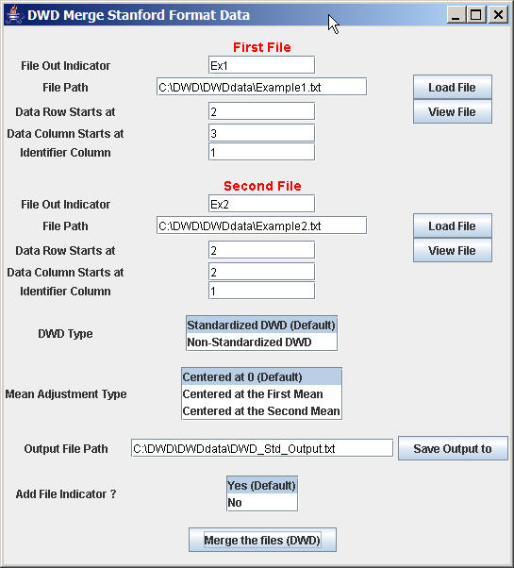
Figure 3. Window to select input parameters to merge Stanford-style formatted input files

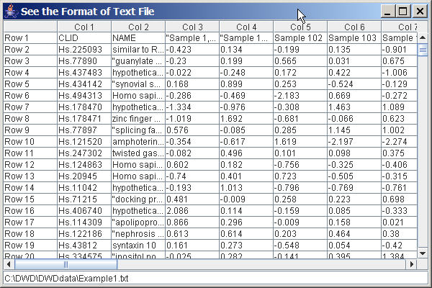
Figure 4. Preview of the contents of the first input data file

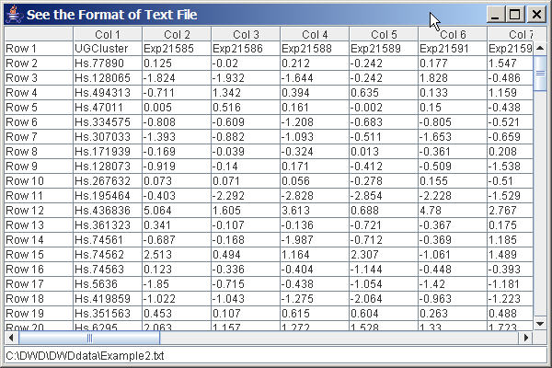
Figure 5. Preview of the contents of the second input data file

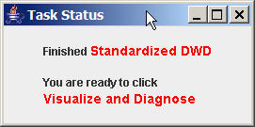
Figure 6. Task Status Window

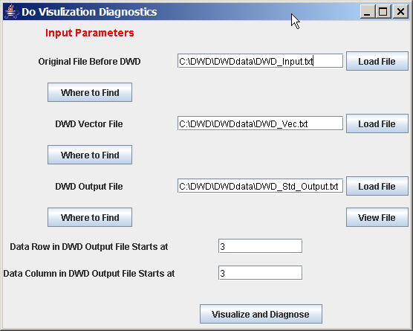
Figure 7. Pop-up window with options to enter the input parameters for the DWD visual diagnostics

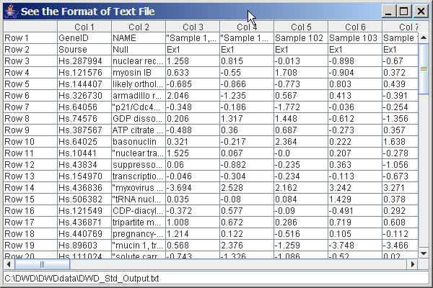
Figure 8. Preview of the contents of DWD_Std_Output File

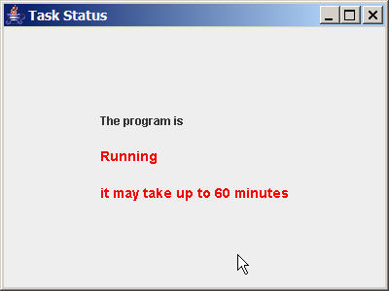
Figure 9. Task status window

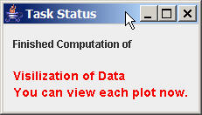
Figure 10. Task status window

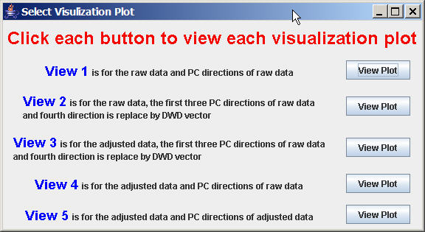
Figure 11. Pop-up window with the choices of visualization plots

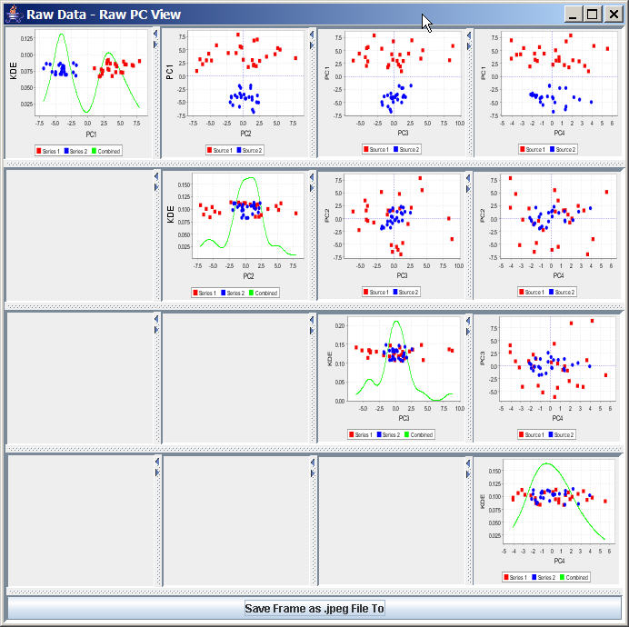
Figure 12. Visualization Plot 1:View of the input data (prior to performing DWD adjustment), projected on the first four principal components evaluated on the input data.

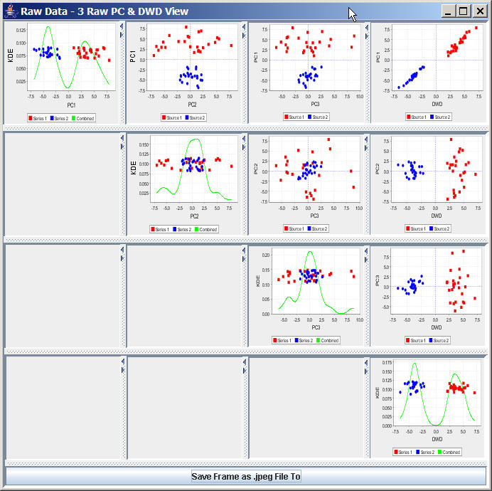
Figure 13. Projections of the input data prior to performing DWD adjustment on the DWD direction as well as the first three principal components computed using the unadjusted input data.

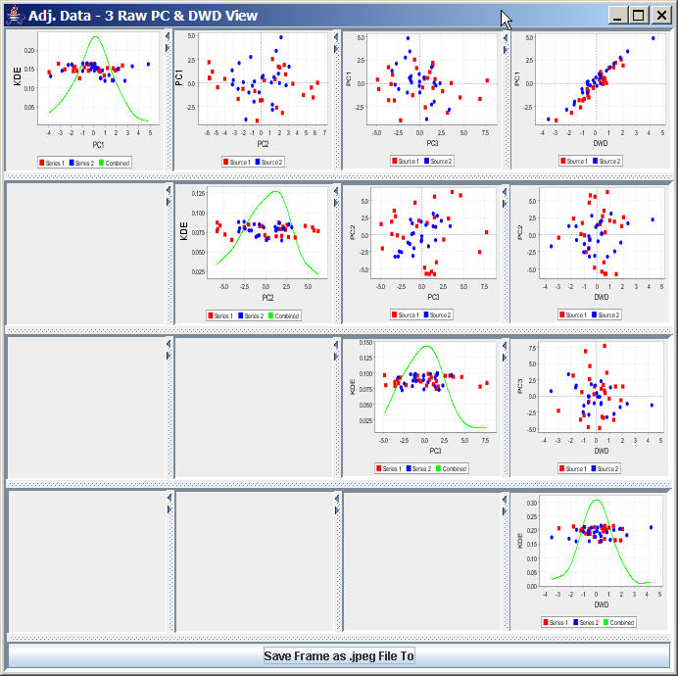
Figure 14. Projections of the DWD-adjusted output data onto the DWD direction as well as the first three principal components computed unadjusted input data

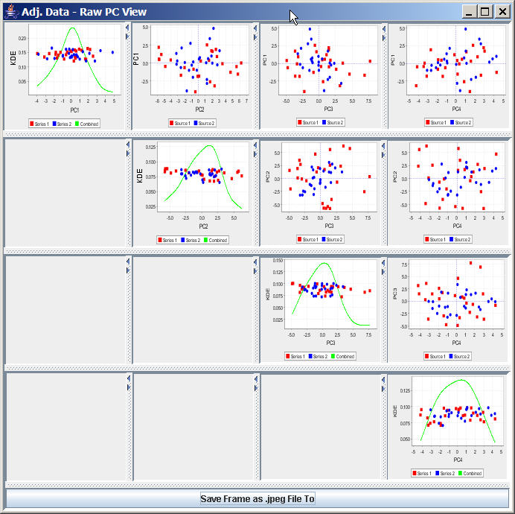
Figure 15. Projection of the DWD-adjusted output data on the first four principal components computed using unadjusted input data

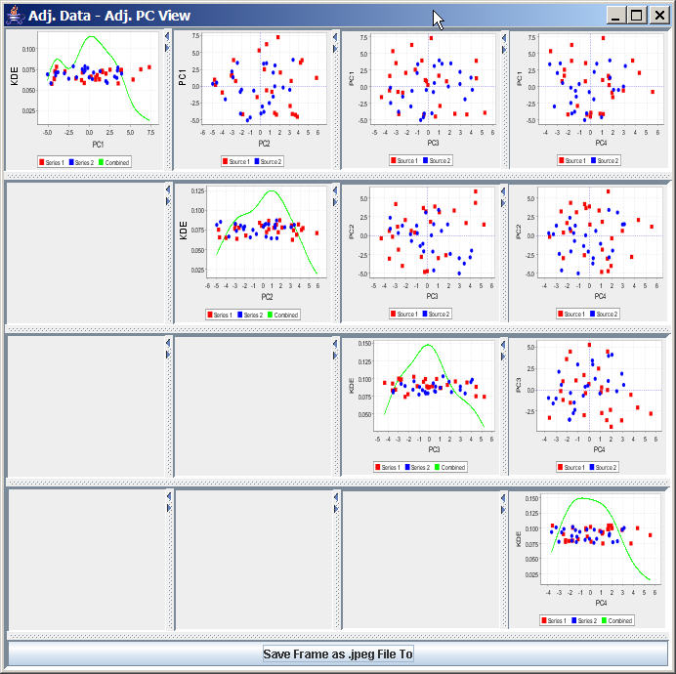
Figure 16. Projections of the DWD-adjusted output data on the first four principal directions evaluated on the output data

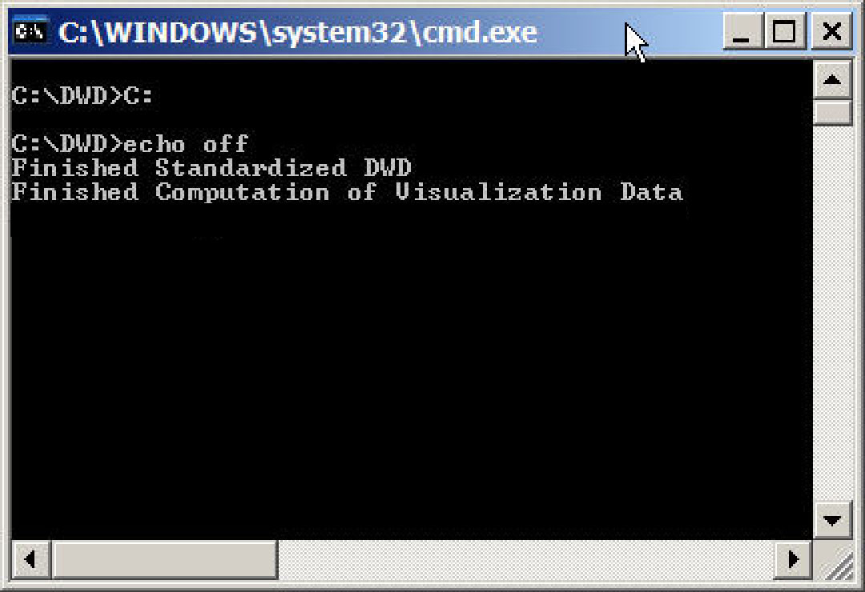
Figure 17. View of the command prompt window after successful completion of DWD-adjustment

Related documents
Other documentation is available for the DWD project, including both on-line documentation and text-based documentation. A current list of user documentation follows.

DWD Software Requirements and Specification
http://cabigcvs.nci.nih.gov/viewcvs/viewcvs.cgi/distanceweighteddiscrimination/DWD_UNC/Month_10/DWD_UNC_Req_Spec_For%20Visualization_Final.doc

DWD User’s Guide (this document)

DWD Administration Manual
http://cabigcvs.nci.nih.gov/viewcvs/viewcvs.cgi/distanceweighteddiscrimination/DWD_Adopter_Wistar/DWD_UNC_caBIGApplicationSystemInstallation-AdministrationReferenceManual_final.doc

DWD User Guide (README.txt)
https://genome.unc.edu/pubsup/dwd/README.txt

DWD test activity log
http://cabigcvs.nci.nih.gov/viewcvs/viewcvs.cgi/distanceweighteddiscrimination/DWD_UNC/Month_11/DWD_UNC_Test_Activity_Log_Complete.doc

For earlier Matlab versions of DWD
https://genome.unc.edu/pubsup/dwd/

The original DWD paper

Marron, J. S. and Todd, M. J. (2002) , Distance Weighted Discrimination, http://www.optimization-online.org/DB_HTML/2002/07/513.html

First application of DWD to microarray data

Benito M, Parker J, Du Q, Wu J, Xian D, Perou CM, Marron JS. (2004) Adjustment of systematic microarray data biases, Bioinformatics 20:105-144.

Startup and termination
This section is intended to describe the procedures for safely starting and shutting down a running application server. But DWD is currently a tool, not a service, so this is not applicable. The section has not been deleted, because it will be useful when DWD becomes a caBIG Analytic Service.

Standard operating procedures
This section is intended to describe the procedures for system maintenance. But DWD is currently a tool, not a service, so this is not applicable. The section has not been deleted, because it will be useful when DWD becomes a caBIG Analytic Service.

Sign Off
Louise Showe LOUISE SHOWE 01/04/06

Adopter Rep Name Date

- Glossary
Following is a list of terms and their definitions.
Term | Definition
caBIG | cancer Biomedical Informatics Grid
DWD | Distance Weighted Discrimination
GUI | Graphical User Interface
MAGE - ML | MicroArray and Gene Expression – Markup Language

